Hedabot
Introduction
The module is used to manage the telegram bot interface of the AATC program. This bot allows users to manage drones via the telegram service instead of the python interface. The program is run on the server and uses mostly the same functions as the conventional user interface, however the program retains it’s state for keeping track of the UserID for each chat rather than keeping a single process for each User in the conventional server manner. The system has to keep track of each session in the database as otherwise the bot would have to keep an active process for each user, which would greatly increase the memory usage of the program.
As the telegram API only allows a bot to connect via a single connection and is not allowed to share this connection between processes to prevent the SSL from failing there is only a single main process for the bot. In order to parrellise the system and increase the maximum throughput the program creates a number of InputSorter processes , these sort the inputs to values such as adding a value, cancelling a command, executing a command, the result being returned to the main process. If a command should be executed then the task is sent to a CommandExecutor process where it is run and the result returned to the main process.
The bot must also retain the state of each chat so that it is able to return the correct response to a query or send the correct question. For example if the user is logging in and has entered the username the program should correctly send the next message as a query to obtain the password such as “password >>”. Additionally the previous inputs from the user should be stored such that the entire command may be executed at once. This is done by creating a stack table in the database which keeps track of all the inputs such that they may be all collected at a later point to be run as part of a command.

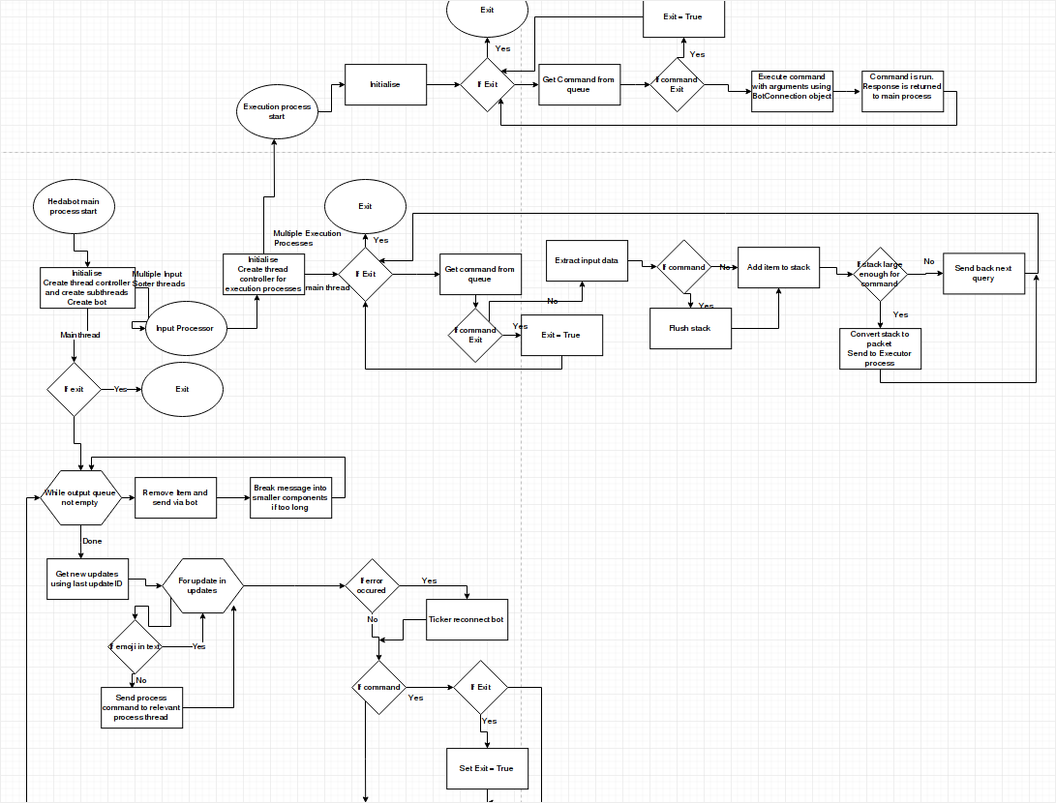

Import
The program requires the telepot module to work with the telegram API. The time module is required to keep track of the number of messages sent per second. The random module is used for small testing programs. Multiprocessing is required for the queues between the processes. The AATC_DB module is required to access the database. The AATC_GPIO module is required for the thread_controller system. SkyrimQuote is a small testing module and is irrelevant to the project. The AATC_Server module is required for access to server features.

Misc
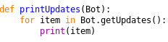
The printUpdates procedure is used for testing to display all incoming messages, taking these messages from the Bot.getUpdate method.

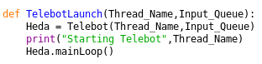
The TelebotLaunch procedure is used to launch the bot, taking the thread_name and input_queue arguments, any and queue types respectively , instanciates the bot and launches it via the mainLoop method.

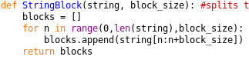
The StringBlock function is used to split a message into blocks the size of the value block_size. The telegram API only allows messages of length 4096 charaters or less to be sent, therefore long messages must be split into multiple messages to avoid this issue. The function takes each section of the string and adds it to the blocks list, so that the seperate blocks can be sent. The program then itterates through the string until this is complete and returns the blocks.

Ticker
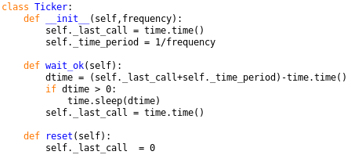
The class Ticker is used to manage the timing of messages sent by the bot. The telegram API only allows 30 messages to be sent per second, otherwise errors are raised and the bot is temporaily locked out of the API. To prevent this the Ticker system keeps track of the last time a message was sent, waiting until it is ok to send the next message.
The Ticker class is instanciated with the maximum frequency desired. The last call attribute stores the last time the system was called. The time period is set to the inverse of the frequency. The wait_ok method is used to wait until the system is ok to proceed. The program calculates the difference in time between when the system may proceed and the current time, if this value is negative (past the time required between calls) the system proceeds, if not the system waits for the required amount of time. Finally the last call is set to the current time. The reset method is used to reset the last call to 0 such that the next call can happen imediatly.

Telebot
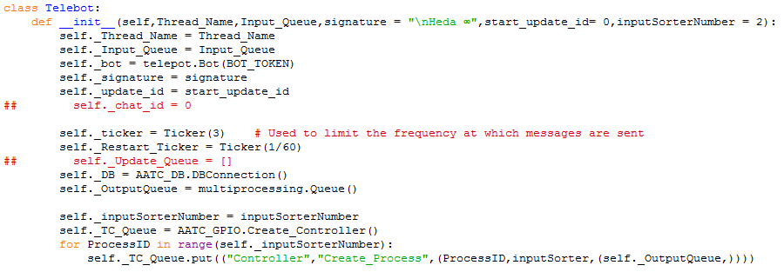
The telebot object manages the input and output functions of the bot. The object initially sorts all input messages and passes them the InputSorters , sends back the processed messages and maintains the connection to the telegram API.
The object takes two required arguments Thread_Name and Input_Queue, containing the name of the thread and the input queue from which the program gets it’s commands. Optionally the signature variable contains the value which all messages end with I.e the name of the bot. The start_update_id contains the base update id ( which messages the bot should start at first) and the inputSorterNumber contains the number of input sorter processes to use ( per default this is 2, the larger the number the more concurrent processes will be able to process messages , however this increases the memory usage. The more users using the program the greater this number should be).
The general attributes Thread_Name, Input_Queue,signature , start_update_id (stored in update id) and input sorter number are stored. The telepot.Bot is created using the BOT_TOKEN value, containing the bot API token, this bot object is used to communicate with the telegram API. The Ticker attribute is used to control the rate at which messages are sent, preventing the bot being locked out from the API system, per default this is set to 3Hz but can be increased to the normal limit of 30Hz. The Restart Ticker system is used to control the rate at which the system restarts if an error occurs, if an error occurs the bot object is recreated, sending a request via the telegram API however if there is an error frequently i.e. the bot token is incorrect an error will be raised again, resulting in a rapid loop causing the API to lock out the bot. The Restart Ticker therefore makes the bot wait 30 seconds between restarts.
A connection to the database is created, and an Output Queue is created to move outgoing messages between processes, allowing the other processes to send messages back to the chats via the main process’ connection to the API.
A thread controller is created and an inputSorterNumber number of processes running the input sorter class with the Output_Queue as an argument and ProcessID ( from 0 → inputSorterNumber -1) are created. These processes run the inputSorter task, sorting the inputs separately from the main process in order to reduce load on the main thread.

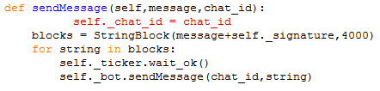
The sendMessage method is used to send messages back to the relevant chat. This requires the string message to be sent as well as the chat_id of the target chat. The message is merged with the signature ( the signature is at the end of every message), and broken into 4000 character blocks to prevent the API from rejecting the message if it is too long. The program then sends each substring from the blocks list to the relevant chat, after waiting for the ticker to allow the program to proceed (preventing the bot sending more than 30 messages per second if the ticker is set to 30).

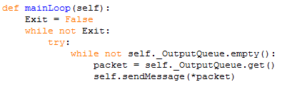
The mainLoop method runs the main section of the bot’s program. The bot will continuously loop until the Exit flag is set to false. As errors may occur while running the program the main section is placed in try/except brackets, catching errors such as a connection failure to the telegram servers.
First the program checks for messages in the output queue, which contains the messages which the bot should send back to the chats, obtaining the packets from the queue and sending the response using the sendMessage method with the contents of the packet as arguments.

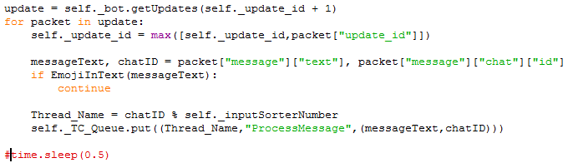
Once the responses have been sent the program obtains all messages sent to the bot are obtained using the getUpdates method of the bot. The updateID is used to obtain the new messages for the bot, keeping track of the updateID prevents the bot from getting old messages again and so causing issues in the program.
The packets in the update are iterated through and the updateID is set to the highest updateID throughout the iterations (always selects maximum, so will find maximum once all items are iterated through). The text and chatID of the message are obtained from the packet ( a dictionary containing information about the message). The program then checks for Emojis/undesired characters which may cause issues later in the program, if one is found then the program will skip the message. If not the Thread name is deduced from the modulus of the chatID by the number of input sorters, evenly distributing the load across each of the input sorters while ensuring that messages from the same chat will be processed linearly by the program ( i.e. preventing messageA being run after messageB). The InputSorter process with the correct thread name is then sent the command to process the message , passing the message text and chatID as arguments.

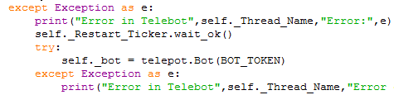
Should an exception have occurred in the main loop of the program this except bracket will catch it. The error message is displayed to the observer and the restart ticker is called to ensure the bot does not attempt to restart too frequently. The bot then attempts to reconnect to the telegram API by instantiating the bot object again, however this may raise an exception if the program cannot connect to the telegram servers. This is then caught by the second pair of try/except statements and displays the relevant error to the observer.

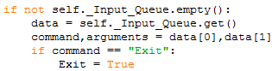
Once the message section has been completed the program checks the Input_Queue for commands , i.e. the exit command if the process controlling the bot would like the bot to exit. If the queue is not empty the data is obtained from the queue, split into the command and arguments and the relevant command is run. Currently only the Exit command is in use, causing the bot to exit.

When the bot exits it will signal to the created Thread_Controller to also exit and to wait for the sub processes to exit as well. The bot will then print an exit message and exit.

InputSorter
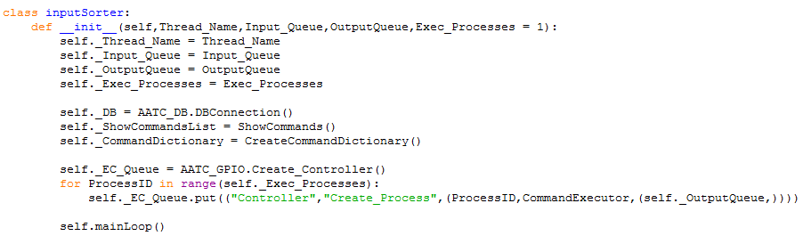
The inputSorter class is used to sort/process the message inputs for the bot. This is run on a separate process to the bot itself in order to increase message throughput. The object takes the Thread_Name, Input_Queue , Output_Queue and Exec_Processes parameters when instantiated. All of the parameters are placed into attributes. A connection to the database is formed and the ShowCommandsList is generated, containing a string of each of the possible commands which can be used. Additionally a command dictionary is created as an attribute. The EC queue attribute is the command queue to the Thread_Controllers over which the Command Executors are controlled. Using this queue Exec_Processes number of CommandExecutor processes are created with Thread_Names 0→ Exec_Processes-1 and the Output_Queue as an argument. Finally the mainLoop is run.

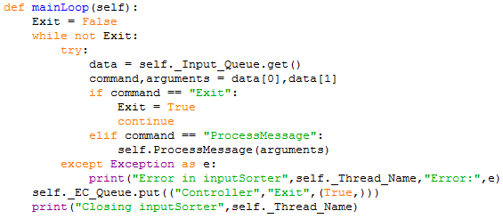
The mainLoop method runs until the Exit variable is set to False. The program continously loops through, obtaining data from the input queue, splitting this data into command and arguments and executing the relevant command. Should the command be exit the inputSorter will exit, if it is Process message the inputSorter will process the message using arguments as an argument to the ProcessMessage method. Should an error have occurred in this loop then the try/except statements will catch the exception and display the error to the observer. Once the main loop has completed the program will send the exit command to all of the Command Executor processes and displays a closing message.

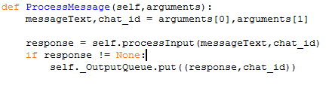
The ProcessMessage method is used to initiate the processing of a message. The messageText and chatID are obtained and the response obtained from the ProcessInput method using these inputs. If the response is not empty then the response is placed in the output queue with the chatID so that it can be sent by the main process.

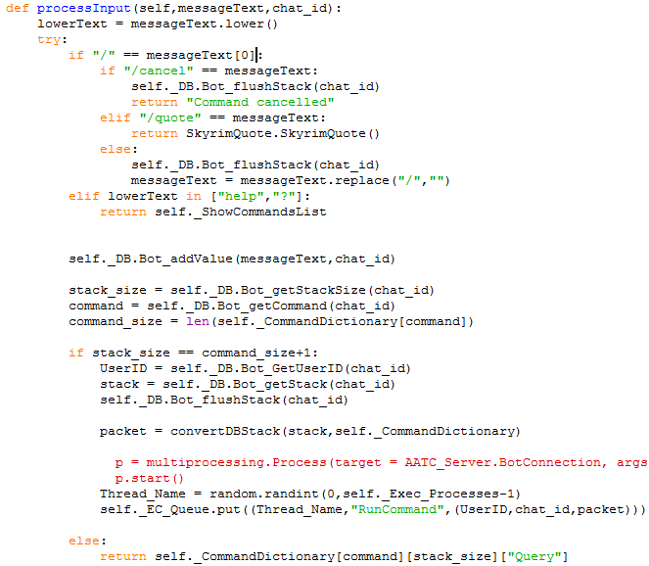
The process input method is used to process the input message. This involves adding commands, managing the command stack, sending commands to be run etc. The method takes the string messageText argument and the integer chatID. First a lowercase version of the text is created and placed in the lowerText variable. Then the program checks if a slash is the first character, if it is the message will be assumed to be a command. Should the command be to cancel then the stack is flushed, cancelling the current command. Should the command be quote then a random quote is obtained using the Skyrim Quote module ( Note: this is merely used as a test function and is not needed for the actual system, it can be commented out/ removed if desired). If the command does not match any of the previous items it is assumed to be a generic command, therefore the previous commands are removed and the slash is removed from the command text and the program continues.
The program then adds the current value (either a parameter or command) to the stack for the given chatID. The current stack size is obtained as well as the current command and command size (number of parameters for that command). Should the stack_size be equal to the command_size +1 ( the number of items in the stack (command + parameters) is the same as the number of parameters needed for the command + 1 ( as command is counted on the stack size)), then the program will obtain the current UserID for that chat ( -1 if not yet used or not logged in) and obtain and flush the entire stack. The stack is then converted into a packet using the convertDBStack function, converting each parameter into the correct type from string as well as forming the correct packet structure. A random Thread is then chosen and the Command Executor Process of that name is told to run the command for the given UserID,chatID and packet.
Should the size of the stack not yet be sufficient then the next query is returned using the command dictionary , with the command and stack size selecting the correct query.

Should an error have occurred it will be caught and the error message returned to the user with the command list to guide them.

CommandExecutor
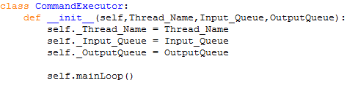
The CommandExecutor class is used to run the commands for the bot when needed, the program acts as a host for the command to run and sends back the response once completed. The class requires the parameters Thread-Name, Input_Queue and OutputQueue which controls the name of the thread, provides a method to pass commands to the object and a queue to return the message once completed respectively. The parameters are placed into attributes and the main loop method is called.

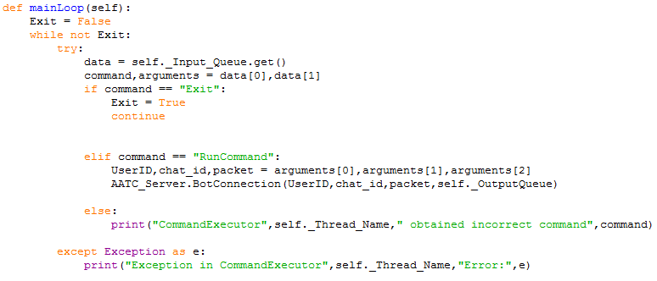
The main loop method runs continuously until the Exit variable is set to false. The program obtains the data from the Input_Queue and obtains the command and arguments from this data. If the command is Exit the loop will exit. If the command is RunCommand the UserID,chat_ID and packet are obtained from the arguments variable and the BotConnection object from the AATC_Server module which is then started with these variables as well as the output queue. This object will then execute the command and send the response back to the main process via the OutputQueue. Should the command not match any of the defined commands an error message will be displayed so that it is visible that the program has not been configured completely.
Should an error occur in this loop it will be caught in the try/except statement and an error message will be displayed.

Misc 2
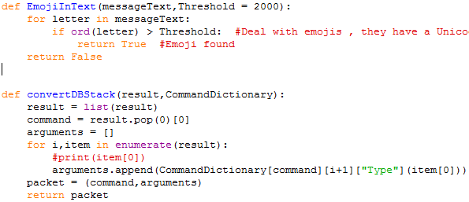
The EmojiInText function is used to detect emojis in the text which can cause errors while processing. These are filtered by checking that each letter in a message has a character unicode number of less than the threshold, per default this is 2000. Should such a letter be encountered the program returns True, otherwise False

The ConvertDBStack function is used to convert a stack of items into a packet format of (command,(Arg1,arg 2….)) with the correct types using the results list from the stack and the dictionary command dictionary. The program converts the results into a list and sets the command to the first item in the stack/result. An empty arguments list is created and the program enumerates through each item in the remaining stack. The items in the stack are converted using the command dictionary to the correct type. This converted argument is added to the arguments list. The packet is then formed and returned.

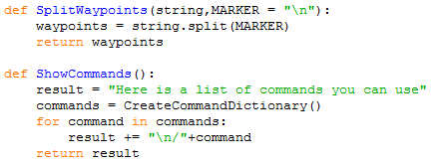
The SplitWaypoints method is used to convert a number of waypoints passed by the user into a list of the same item. The program takes a string and splits the string along the marker , per default this is the new line character. This is used by the CommandDictionary to convert the waypoints sent by the user ( in a waypoint per line format) into a list format used by the AATC_Server.

The ShowCommands function is used to obtain a string representation of the possible commands , created using a short start message and adding each command from a command dictionary to a new line. The result is returned

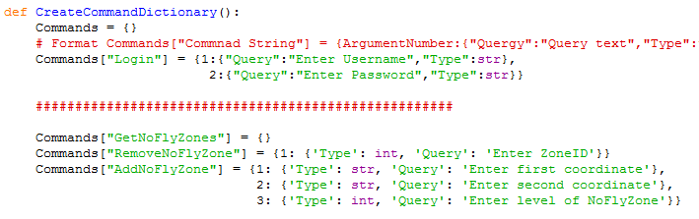
CreateCommandDictionary is used to create a command dictionary. A command dictionary is used by the bot to run the commands with the correct queries in the correct order. For a given command in the dictionary there is a dictionary with a key -value pair of QueryNumber-QueryDictionary. The query dictionary contains the query which the user should be sent as well as the type the item should be of ( note this value must be able to take a string as an argument and return the converted object eg int(“51”) → 51 ). This allows the bot to automatically send the queries and convert types without having to alter the actual code for each command. Adding a new command simply requires a new command in the dictionary. This structure allows further interfaces to be created easily such as possibly a flask web app ( tested but not part of the NEA, just a proof of concept) or modified text interface or tkinter menu.
This function is very long and finally returns the command dictionary.

The BOT_TOKEN constant contains the API key used to connect to the telegram servers. This should be kept secret unless the bot is not of value.

